Jane Austen (1775-1817)

Biographical note
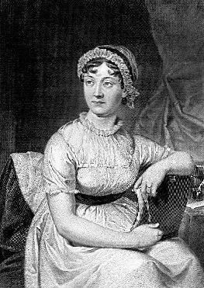
Novelist, daughter of a clergyman, was born at the rectory of Steventon near Basingstoke. She received an education superior to that generally given to girls of her time, and took early to writing, her first tale being begun in 1798. Her life was a singularly uneventful one, and, but for a disappointment in love, tranquil and happy. In 1801 the family went to Bath, the scene of many episodes in her writings, and after the death of her father in 1805 to Southampton, and later to Chawton, a village in Hants, where most of her novels were written. A tendency to consumption having manifested itself, she removed in May, 1817, to Winchester for the advantage of skilled medical attendance, but so rapid was the progress of her malady that she died there two months later. Of her six novels, four — Sense and Sensibility (1811), Pride and Prejudice (1813), Mansfield Park (1814) and Emma (1816) — were published anonymously during her life-time; and the others, Northanger Abbey — written in 1798 — and Persuasion, finished in 1816, appeared a few months after her death, when the name of the authoress was divulged. Although her novels were from the first well received, it is only of comparatively late years that her genius has gained the wide appreciation which it deserves. Her strength lies in the delineation of character, especially of persons of her own sex, by a number of minute and delicate touches arising out of the most natural and everyday incidents in the life of the middle and upper classes, from which her subjects are generally taken. Her characters, though of quite ordinary types, are drawn with such wonderful firmness and precision, and with such significant detail as to retain their individuality absolutely intact through their entire development, and they are never coloured by her own personality. Her view of life is genial in the main, with a strong dash of gentle but keen satire: she appeals rarely and slightly to the deeper feelings; and the enforcement of the excellent lessons she teaches is left altogether to the story, without a word of formal moralising. Among her admirers was Sir W. Scott, who said, “That young lady has a talent for describing the involvements of feelings and characters of ordinary life which is to me the most wonderful I ever met with;” others were Macaulay (who thought that in the world there were no compositions which approached nearer to perfection), Coleridge, Southey, Sydney Smith, and E. FitzGerald.

